Dr. Zahoor Ahmad Itoo
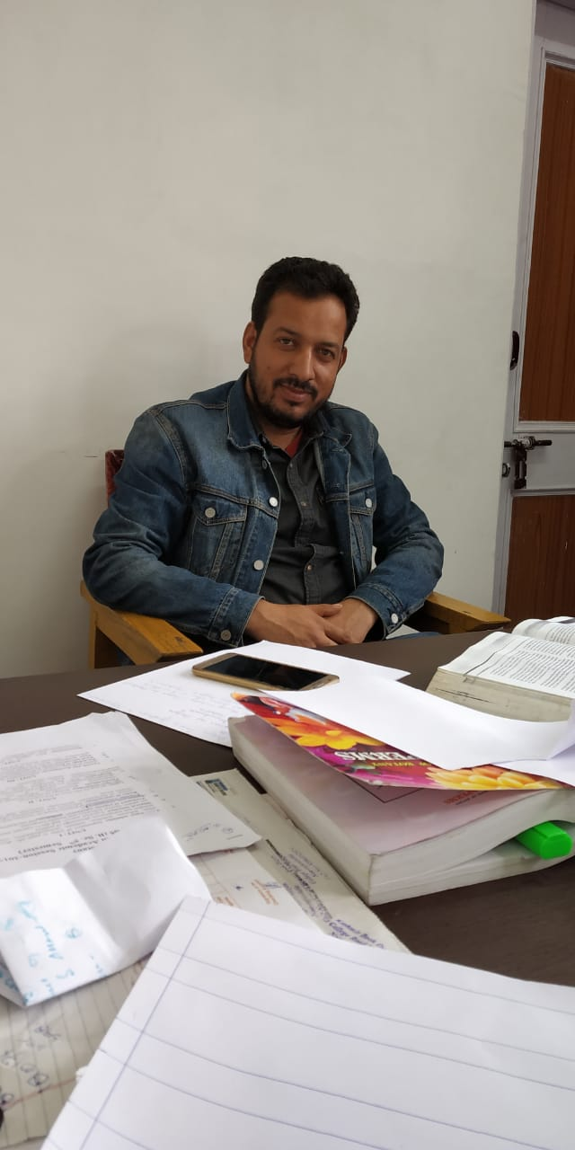
M.Sc ,M.Phil , M.ED, P.hD
NET
PERSONAL DETAILS
Name Zahoor Ahmad Itoo
Parentage Ali Mohammad Itoo
Permanent address Sonigam, Kulgam
District Kulgam
State Jammu and Kashmir
Pin code 192232
D. O. B. 06-04-1984
Nationality Indian
Position Assistant Professor (4/7/2017 Date of Joining)
Academic qualification
- M.Sc (Botany) from University of Kashmir, Srinagar
- Joint CSIR/UGC NET (LS) in Life Science in 2007
- Joint CSIR/UGC NET (LS) in Life Science in 2008
- M.Phil from Department of Botany University of Kashmir, Srinagar
- B.ED from University of Kashmir, Srinagar
- M.ED from University of Kashmir, Srinagar
- PhD from Department of Botany, University of Kashmir, Srinagar
- Achievements
- Qualified joint CSIR/UGC NET (LS) in Life Science held on 18-12-2007
- Qualified joint CSIR/UGC NET (JRF) in Life Science held on 18-06-2008
- Completed research project on Molecular characterization of ectomycorrhizal fungi sponsored by Department of Biotechnology, Govt. of India
- Participated and presented research papers in symposia and national level conferences
- Awarded Doctor of Philosophy in Botany by University of Kashmir, Srinagar on 30 June 2014.
- More than 40 GenBank accessions.
- Patent submitted on “Inhibition of S6KI activity by ethanolic mushroom extracts” under number 16222
- Attended 7th Young Investigators Meeting held in Srinagar from 27-03-2015 to 1-4-2015.
- Reviewer for Journal of Advances in Biology and Biotechnology.
- Member of Consortium for Educational Communication.
Research Papers presented in Conferences and Symposia
- Ectomycorrhizal diversity associated with Pinus wallichiana and Cedrus deodara in Kashmir Himalaya, India.
Zahoor Ahmad Itoo, Zafar Ahmad Reshi
(National Conference on Biodiversity: present status and future challenges, Department of Botany, University of Kashmir, 26-28 March 2009, Abs. 9. pp 50- 51)
- Diversity of ectomycorrhizal fungi of some important conifers of Kashmir Himalayas.
Balwant Verma, MS Reddy, Zahoor Ahmad Itoo, Zafar Ahmad Reshi, Balwant Verma, M. S. Reddy
(Presented at 35th Annual Meeting of the Mycological Society of India (MSI) held in Chennai on 29th & 30th January, 2009
- Ectomycorrhizal diversity of Kashmir Himalaya, India: An untapped resource.
Zahoor Ahmad Itoo, Zafar Ahmad Reshi
(National seminar on Himalayan Resources: Issues , Challenges and Management Strategies, organized by the Department of Geography and Regional Development, University of Kashmir, Srinagar, Jammu and Kashmir.
- Effect of different nitrogen and carbon sources and concentrations on the mycelial growth of ectomycorrhizal fungi under in-vitro conditions.
Zahoor Ahmad Itoo, Zafar Ahmad Reshi
(8th JK Science Congress 2012 Science, Technology and Regional Development: Opportunities and Challenges” University of Kashmir, J &K state council for S&T and DST, GOI)
- Characterization and Identification of Ectomycorrhizal Fungal Species from Kashmir Himalaya by PCR Analysis of the rDNA Internal Transcribed Spacer (ITS). Zahoor A Itoo, Zafar A Reshi, Khurshid I Andrabi.(9th JK Science Congress 2013 & Regional Science Congress)
- Diversity of ectomycorrhizal Amanita species from Kashmir Himalayan Coniferous Forests. Zahoor A Itoo, Zafar A Reshi (9th JK Science Congress 2013 & Regional Science Congress)
- Wild mushrooms as a source of lead metabolites with chemotherapeutic potential. Zahoor Ahmad Itoo, Sheikh Tahir Majeed, Qussin Basharat, Zafar A Reshi, Khurshid I Andrabi. Poster presentation on international conference on Cellular and Molecular Mechanisms of Disease Processes
- Diversity of Arbuscular Mycorrhizas associated with Saffron in the Kashmir valley, India. Zahoor Ahmad Itoo, Zafar A Reshi, Manzoor A Shah.
Abstract accepted for presentation at 8th international conference on mycorrhiza to be held in USA.
- Mushrooms as a source of lead metabolites with chemotherapeutic potential. Zahoor Ahmad Itoo, Zafar A Reshi, Sheikh Tahir Majeed, Qussin Basharat, Khurshid I Andrabi National Symposium on Biodiversity, Biology and Bioprospecting organized by the Department of Botany, University of Kashmir, Srinagar.
Research papers published
- Zahoor Ahmad Itoo, Zafar A Reshi. Ectomycorrhizal diversity associated with Cedrus deodara and Pinus wallichiana in the Kashmir Himalaya, India. Pakistan Journal of Biological Sciences. Dol: 10.3923/pjb.2013
- Zahoor Ahmad Itoo, Zafar A Reshi, Khurshid I Andrabi. Characterization and identification of Russula firmula and Russula postiana from Himalayan moist temperate forests of Kashmir. African Journal of Biotechnology 12: 3643-3647
- Zahoor Ahmad Itoo, Zafar A Reshi. Influence of ectomycorrhizal inoculation on Pinus wallichiana and Cedrus deodara seedlings under nursery conditions. Frontiers in Biology DOI 10.1007/11515-014-1292-4
- Zahoor Ahmad Itoo, Zafar A Reshi. Diversity of ectomycorrhizal Amanita species from Kashmir Himalayan coniferous forests. International Journal of Current Research 6: Issue, 02, 2014
- Zahoor Ahmad Itoo, Zafar A Reshi. The Multifunctional Role of Ectomycorrhizal Associations in Forest Ecosystem Processes. Botanical Review 79:371–400
- Zahoor Ahmad Itoo, Zafar A Reshi. Effect of different nitrogen and carbon sources and concentrations on the mycelial growth of ectomycorrhizal fungi under in-vitro conditions. Scavandian journal of forest research.
- Zahoor Ahmad Itoo, Zafar A Reshi. Diversity of ectomycorrhizal macromycetes associated with Cedrus deodara and Pinus wallichiana in the Kashmir Himalaya, India. African Journal of Plant Sciences.
- Zahoor Ahmad Itoo, Sheikh Tahir Majeed, Qussin Basharat, Zafar A Reshi, Khurshid I Andrabi. Characterization and identification of Inocybe geophylla and Inocybe mimica from temperate forests of Kashmir Himalaya, India. Jk Knowledge Initiative
- Zahoor Ahmad Itoo, Sheikh Tahir Majeed, Qussin Basharat, Zafar A Reshi, Khurshid I Andrabi. Characterization of ectomycorrhizal Cortinarius species (Agaricales, Basidiomycetes) from temperate Kashmir Himalaya, India. Advances in Molecular Biology.
- Zahoor Ahmad Itoo, Sheikh Tahir Majeed, Qussin Basharat, Khurshid I Andrabi, Zafar A Reshi. Ectomycorrhizal fungal species of Kashmir Himalaya: identification and characterization by ITS analysis. Brazilian Journal of Botany. 10.1007/s40415-014-0081-2.
- Zahoor Ahmad Itoo, Zafar A. Reshi, Sheikh Tahir Majeed, Qussin Basharat, Khurshid Iqbal Andrabi. Morphological and Molecular Characterization of Ectomycorrhizal Amanita Species Associated with Pinus wallichiana A. B. Jacks. Proc. Natl. Acad. Sci., India, Sect. B Biol. Sci. DOI 10.1007/s40011-015-0527-
- Zahoor Ahmad Itoo, Zafar A. Reshi, Sheikh Tahir Majeed, Qussin Basharat, Khurshid Iqbal Andrabi. Inhibition of S6KI acitivity by ethanolic mushroom extracts. Patent Office Journal No.2271/DEL/2014 A
- Zahoor Ahmad Itoo, Zafar A. Reshi. Ectomycorrhizal Lactarius species associated with Pinus wallichiana in Kashmir Himalaya India: Characterization and Identification through Morphological and Molecular approaches. Journal of Forestry Research.

RESEARCH PAPERS COMMUNICATED
(UNDER REVIEW)
- Zahoor Ahmad Itoo, Sheikh Tahir Majeed, Qussin Basharat, Zafar A Reshi, Khurshid I Andrabi. Molecular characterization of some wild mushroom species from Himalayan temperate forests of Kashmir, India using ITS-rDNA barcoding. Ecology and Evolution.
- Zahoor Ahmad Itoo, Zafar A Reshi. Characterization and identification of ectomycorrhizal mushrooms from temperate forests of Himalaya, India through ITS-rDNA barcoding. Biodiversity and Conservation.
- Zahoor Ahmad Itoo, Zafar A Reshi, Khurshid I Andrabi. Characterization and Identification of Scleroderma species from Himalayan Moist Forests of Kashmir. Brazilian Journal of Microbiology.
- Zahoor Ahmad Itoo, Zafar A Reshi, Khurshid I Andrabi. Characterization and identification of ectomycorrhizal Rhizopogon species from temperate Kashmir Himalaya by PCR analysis of the rDNA internal transcribed spacer (ITS). Mycorrhiza.

