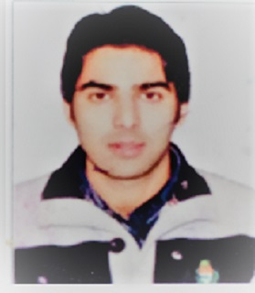
MASR00F AHMAD MALIK
Address ;- Sopat. Teh. Devsar. . Distt.Kulgam. E.mail:Malikmasroof12@gmail.cm
Mobile## 7051728590,
Career Objective: Dedicated to creating a positive learning environment and making a difference in student’s lives by providing them superior teaching skills.________________________________________
Education:

Teaching as lecturer in Govt degree college, kulgam since,2017.

Qualified jk state elligibilty test( jkset): Conducted by jkset agency, university of kashmir.

Master of science(Msc). Biochemistry, university of kashmir.
Bachelor of science(Bsc); university of kashmir_______
Areas of Teaching:
- Biomolecules

- Enzymology
- Immunology
- Cell Biology
- Molecular biology
- Analytical techniques

