CURRICULUM VITAE

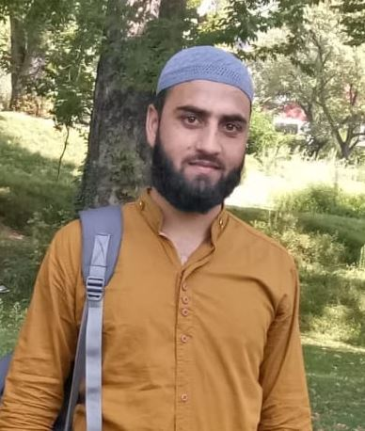
Personal Profile
Safeer Ahmad Bhat
Assistant Professor
Department of History,
Government Degree College, Kulgam
University of Kashmir (India)
Mobile: +91 985874597
Email: safeer.hist@gmail.com, safeer63@gmail.com

Academic Qualifications:
- M.A History (Gold Medalist) from University of Kashmir, Srinagar June 2014;
Main Courses Studied: Socio-Political, Economic and Cultural History of Ancient, Medieval and Modern India, History of Kashmir from Ancient to Modern Times, History of Modern World and Historiography.

- B.A with 69.17% from University of Kashmir, Srinagar March 2012
Main Subjects Studied: English Literature, History and Political Science.
Technical Skills
- Basic Knowledge of Computer including MS Word, Excel, Spreadsheet and MS PP Presentation.
- Know-How of Internet.
Awards and Academic Distinctions:
- Gold Medalist in M.A. (History)
- Qualified UGC-NET JRF (JRF) in June 2013.
- Qualified J & K SLET conducted by the University of Kashmir, Srinagar in September 2013.
- Secured Distinction in Secondary and Senior Secondary Exams (82.6 and 79.6% respectively).
Languages Known
English, Hindi, Urdu, Arabic and Kashmiri.
Academic Research Interests:
- Islam and Modern Challenges : Islamophobia and Feminism
- South Asian History
- The First National Conference Government in Jammu and Kashmir, 1948-53.
- Violence against Women in Kashmir.
- Origins of the Kashmir Dispute.
- Sheikh Abdullah and his Contested Legacies.
- Identity Politics in Kashmir.
- Emergence of Armed Insurgency in Kashmir.
Publications:.
- Published a Paper titled, ‘Jammu and Kashmir on the Eve of Partition- A Study of Political Conditions’ in South Asian Studies- A Research Journal of South Asian Studies Vol. 32, No. 2, July – December 2017, pp.285 – 295
- Published a Paper titled, ‘India, Pakistan and the Functioning of the Propaganda Machinery over Kashmir-A Comparative Study’ in the Proceedings of 24th International Conference of Historians of Asia (IAHA 2016), Islamabad Pakistan.
Conferences/ Seminars/ Workshops Attended:
- International:
- Participated in Fourth South Asian History Conference on Exploring the Evolution of State and Polity in South Asia: Continuities and Transformations, and presented a paper on, Jammu and Kashmir on the Eve of Partition- A Study of Political Conditions, held on 07-09 October 2016, organized by Department of History, Punjabi University, Patiala.
- Participated in International Conference on Reforms in the 21st Century: Developments and Prospects, held on 10th October 2016, Organised by the Department of Public Administration, Punjabi University, Patiala and presented a paper on, ‘Post-Independence Governance in Jammu and Kashmir, 1948-53- Issues and Challenges’.
- Participated in Sixth South Asian History Conference on ‘Mapping the Marginalised in South Asia with Special reference to the Legacy of Guru Nanak Dev’ held on 1-3 February 2019 at the Department of History, Punjabi University Patiala and Presented a paper on ‘Muslim Conference in Retrospect: A Study of Revival, Organisation and Role in Jammu and Kashmir, 1941-53’.
- National:
- Attended National Workshop on ‘Research Methodology’ held on 21-22 March 2015, Organised by the Department of Sanskrit, Aligarh Muslim University, Aligarh, UP-202002.
- Attended Workshop on “Human Rights-National and International Perspectives” held on 23rd-29th March 2015, Organised by the Department of Political Science, Aligarh Muslim University, Aligarh in association with U.G.C., New Delhi.
- Participated in One day Seminar on ‘Kashmir in Creative Writing: A Critical Study in Themes and Approaches’ on 25th of March 2017’ and Presented a paper on ‘Creative Writing and Kashmir Insurgency: A Study of Half Mother and Scattered Souls’.
- Participated in many Debates and Seminars on a wide range of Topics and won many Prizes at Intra and Inter College Levels.

Correspondence Address:
88- Murad Pora,
Shopian, Kashmir (J & K).
192303.

