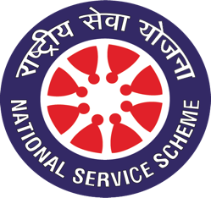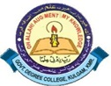**National Service Scheme (NSS) Unit**

**Govt. Degree College, Kulgam**

**Email:** [nss.gdckulgam@gmail.com](mailto:%20nss.gdckulgam@gmail.com) **Tel. No:** 01931-260177

**Website:** [*http://gdckulgam.edu.in*](http://gdckulgam.edu.in)**Fax No:** 01931-260177

No: GDCK/NSS/22/41 Date: 03-06 -2022

**Celebration of World Bicycle Day on 3rd June, 2022**

Under the aegis of Azadi ka Amrit Mahotsav and Fit India, National Service Scheme (NSS) Unit in collaboration with the Department of Physical Education and Sports of the College celebrated World Cycle Day on 3rd June, 2022 under the slogan **‘Live** **Better, Stay Fit. Ride a Bicycle!’**. Around 30 NSS volunteers participated in the cycling event, besides members from the teaching and non-teaching staff. The event was flagged off by Prof. (Dr.) Manzoor Ahmad Lone, Principal of the College from the main gate of the College. In his interaction with the participants, he talked about the benefits of riding bicycles and exhorted the students to make cycling a part of their habits. The Cycle rally passed by all the departments of the College and spread the message of using cycles for saving the planet. Earlier, Dr. Safeer Ahmad Bhat, NSS Programme Officer and Mr. Waseem Ahmad Mantoo, PTI, deliberated on the importance of using bicycles in reducing stress and remaining fit. It was held that it was imperative to use bicycles for reducing emissions and making the earth greener and safe for future generations. The event concluded with a pledge on ‘Ride a Cycle, Save the Environment’.

Dr. Safeer Ahmad Bhat



NSS Programme Officer

Copy to:

1. Worthy Principal for information
2. Coordinator IQAC
3. Incharge website
4. Office records