List of students enrolled for the subject tour
S.No | Name | Roll No | Phone No.
1 | Zahid Salam | 190302 | 6006486202
2 | BasitGayaz | 190250 | 7889939351
3 | Fasil Amin Shah | 190412 | 9906524784
4 | Waseem Ahmad Dar | 190314 | 6006246500
5 | IshfaqRahman | 190355 | 9858878809
6 | TahirSubzar | 190414 | 6005174800
7 | Rashid Shafi | 190319 | 9149413343
8 | InshaFayaz | 190416 | 7889799780
9 | AnsarYousf | 190401 | 9149677377
10 | SumayaAyoub | 190301 | 6005583238
11 | WaniamYaqboom | 190353 | 9149672098
12 | Zahoor Ahmad Malik | 190352 | 9149437391
13 | Sartij Ahmad Bhat | 190343 | 7889320974
14 | ShakirChack | 190347 | 9541039288
15 | SuhilShabiir | 190300 | 7889879129
16 | SuzeenaNazir | 190367 | 9596565179
17 | Asif Hamid | 190413 | 6006014099
18 | MuzimulQayoom | 190315 | 8825027746
19 | SharikManzoor | 200409 | 7006725037
20 | SuhilShafi | 200406 | 6006699133
21 | Aabid Bashir | 200424 | 9797180102
22 | Rukiaya Jan | 200301 | 9541564159
23 | RowaidaShameen | 200387 | 6006760045
24 | InayaitFayaz | 200426 | 959629839
25 | MuzamilMukhtar | 200430 | 6005582275
26 | Aaqib Bandy | 200302 | 9541173617
27 | Inam-ulHaq | 200371 | 9149821261
28 | ShahidShabir | 200407 | 8491879243
29 | AhsanRehman | 200425 | 7780985727
30 | SuhaibWani | 210347 | 8082595049
31 | MohsinMukhtar | 210346 | 6005497404
32 | Rohee Amin | 210331` | 6005915546
33 | Kushboo Jan | 210302 | 8491027309
34 | AafaqShabbir | 210349 | 6006830692
35 | ZahidSaree | 210339 | 7889361178
36 | Muzamil Amin | 210294 | 9682383939
37 | AbrahHaq | 210291 | 9541327144
38 | SayedFarhan | 210265 | 6006240051
39 | Nadia Mushtaq | 200066 | 6006951644
40 | MisbhaShafi | 200019 | 6005824414

HOD PHYSICS

1. List of Staff Members
S.No | Name of the Officer/Official | Designation
1 | Dr.Manzoor Ahmad Lone | Principal
2 | Prof Abdul Haleem
3 | Dr. Aijaz Ahmad Wani | Assistant Professor
4 | Dr.MohdIqbal Rather | Assistant Professor
5 | Mukhtar Ahmad | Chokidar
6 | Shabir Ahmad | Driver
7 | Showkat Ahmad | LFA

2. Contact Number and Name of the Tour Co ordinator
Dr. Aijaz Ahmad Wani
Contact No: 7006158969
3. Vechicle Registration No:
JK22 1798

HOD PHYSICS Principal

Report of physics tour to High Altitude Research Laboratory( HARL) Gulmargh.

The department of Physics conducted the subject tour to the High Altitude Research Laboratory (HARL) at Gulmargh accompanied the students of B.Sc having the physics as one of the subject. The subject tour is part and parcel of their practical as well as academics.

High Altitude Research Laboratory (HARL) Gulmargh has its own share of high and scientific research as well. Interestingly there is a BARC lab that could as well become an attraction for visitors. The HARL was established inGulmargh Kashmir inn1963, on the initiative of DR. H.J. Bhaba, to provide the scientific community of the country a self contained high altitude/ high latitude laboratory for scientific research. Over the year a range of scientific research and scientific investigations in the field of ionosphere studies, cosmic ray astrophysics radio astronomy, neutron monitory, etc has been conducted from this laboratory, low energy Neutron monitor is operated at high altitude research lab. Gulmargh, locally relevant Radiation applicator studies and instrumunenation Development activities are being pursued in the Srinagar laboratories.
The students left the college for tour at 7 am sharp on 1/09/2022 and reached their at 11.30 am . After getting gate pass from the concerned department the students along with the staff members entered in the (HARL) by the order of the officerincharge (NRL/HARL) BARC Srinagar, and the scientist concerned of the lab was deputed for our guidance i.e for the students as well as the staff. The scientist concerned of the lab give the details presentation to the students, regarding the activity , Experimental setup, uses of the data of lab (Photograph of lecturer is enclosed). The students also saw the lead force Gulmargh neutron minister which is situated at the first flour of the lab. After vistingthe whole lab the students left the Gulmargh to their respective place.

The physics subject tour is an important and inevitable practice that forms the back bone of a balanced academic exercise of a student. Vesting a place of HARC at Gulmargh.

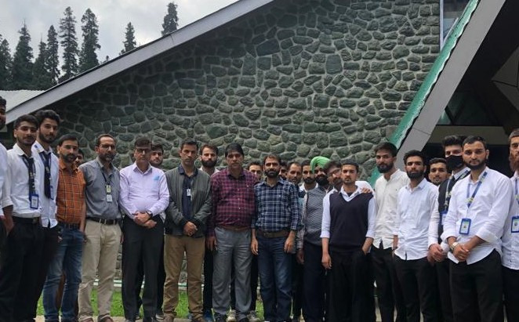

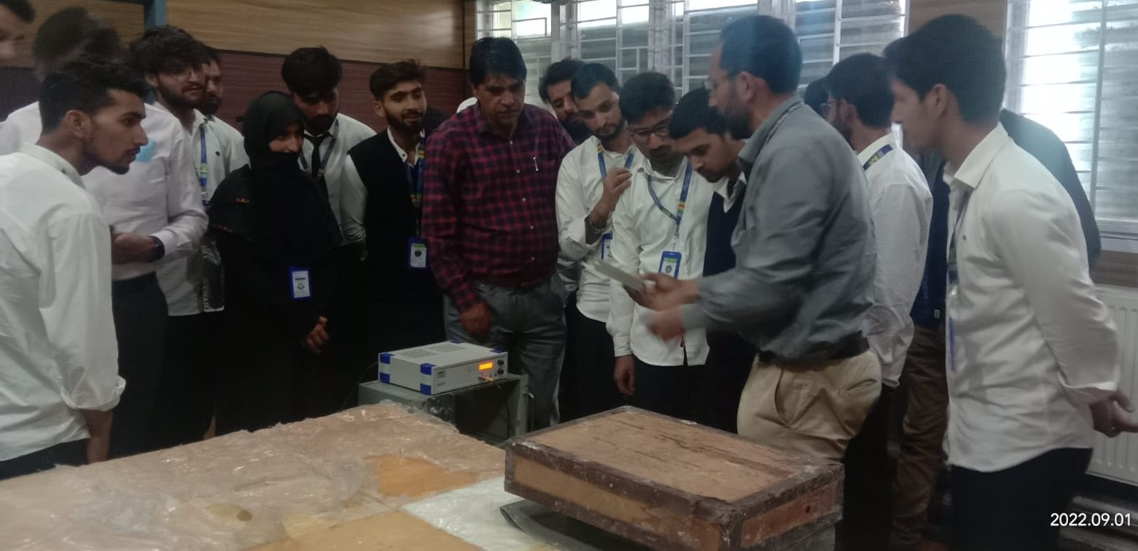

HIGH ALTITUDE RESEARCH LABORATORY GULMARGH

