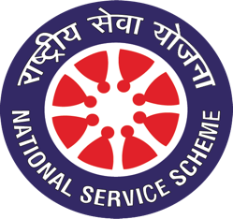
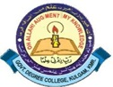
National Service Scheme (NSS) Unit
Govt. Degree College, Kulgam

Email: nss.gdckulgam@gmail.com Tel. No: 01931-260177
Website: http://gdckulgam.edu.in Fax No: 01931-260177

No: GDCK/NSS/22/15 Date: 17-03-2022
Report of the Workshop on Cyber Jagrukta on 16th March, 2022
National Service Scheme (NSS) Unit organised a workshop on Cyber Jagrukta under the theme, ‘Cyber Crimes-A Sociological Perspective’ on 16th March, 2022 in collaboration with ICT of the College. Dr. Shabnum Ara, Dean Students Welfare, Cluster University Srinagar was the keynote speaker for the occasion. The programme was convened in the Conference Hall and was moderated by Mr. Sajad Ahmad Shah, Assistant Professor, Computer Applications. The event saw the participation of around 70 NSS volunteers besides faculty and staff. In his welcome address, Principal of the College, Dr. Nazir Ahmad Simnani stressed on the need to spread cyber awareness and emphasised on the role of conscious civil society members in instilling the consciousness regarding the cyber threats, cyber crimes and frauds. In her keynote address, Dr Shabnum explained in detail the important concepts related to cyber crimes including cyber threats, stalking, phishing, hacking, money laundering and cyber terrorism etc. Students were made aware about different crimes that are punishable under law and were taught as to how to behave as responsible citizens while using the resources available on the internet. The event concluded with a vote of thanks by Dr. Safeer Ahmad Bhat, NSS Programme Officer.

Dr. Safeer Ahmad Bhat

NSS Programme Officer
Copy to:
- Worthy Principal for information
- NSS Advisory Board for information
- Coordinator IQAC
- Incharge Website for uploading the notice on College Website
- Office records

