**Report of a Physics Tour to the High Altitude Research Laboratory (HARL) in Gulmarg.**

**The department of physics conducted the subject tour to the High Altitude Research Laboratory (HARL) at Gulmarg and accompanied the students of** BG- 5th, and 6th semesters **having physics as one of their subjects. The subject tour is part and parcel of their practical as well as academic studies.**

**The High Altitude Research Laboratory (HARL) in Gulmarg has its own share of high-level and scientific research as well. Interestingly, there is a BARC lab that could as well become an attraction for visitors. The HARL was established in 1963 at Gulmarg, Kashmir, on the initiative of Dr. H.J. Bhaba, to provide the scientific community of the country with a self-contained high-altitude or high-latitude laboratory for scientific research. Over the past year, a range of scientific research and scientific investigations in the fields of ionosphere studies, cosmic ray astrophysics, radio astronomy, neutron monitoring, etc. have been conducted from this laboratory. A low-energy neutron monitor is operated at this high-altitude research lab. Gulmarg, locally relevant radiation applicator studies, and instrumentation development activities are being pursued in the Srinagar laboratories.**

**The students left the college for the tour at 7 am sharp on September 5, 2023, and reached the spot at 11.30 am. After getting a gate pass from the concerned department, the students along with the staff members entered the lab by the order of the officer in charge (NRL/HARL) at BARC Srinagar, and the scientist concerned with the lab was deputed for our guidance, i.e., for the students as well as the staff. The scientist concerned with the lab gives a detailed presentation to the students regarding the activity, experimental setup, and uses of the lab's data (photographs enclosed). After visiting the whole lab, the students left Gulmarg for their respective places.**

**The physics subject tour is an important and inevitable practice that forms the backbone of a balanced academic exercise for a student.Vesting a place of HARL at Gulmarg.**

**High Altitude Research Laboratory (HARL) in Gulmarg**

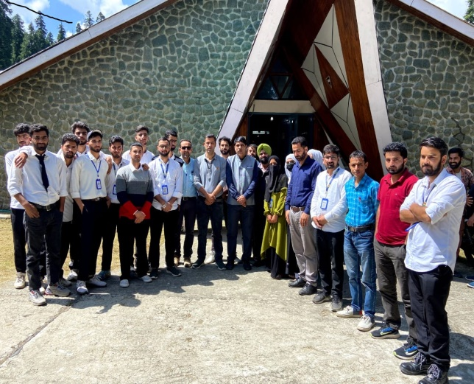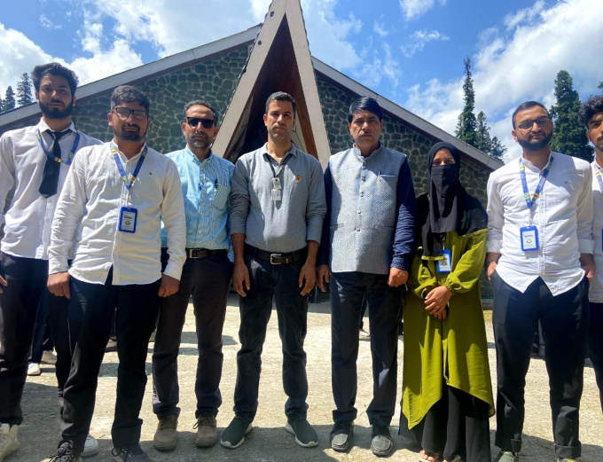

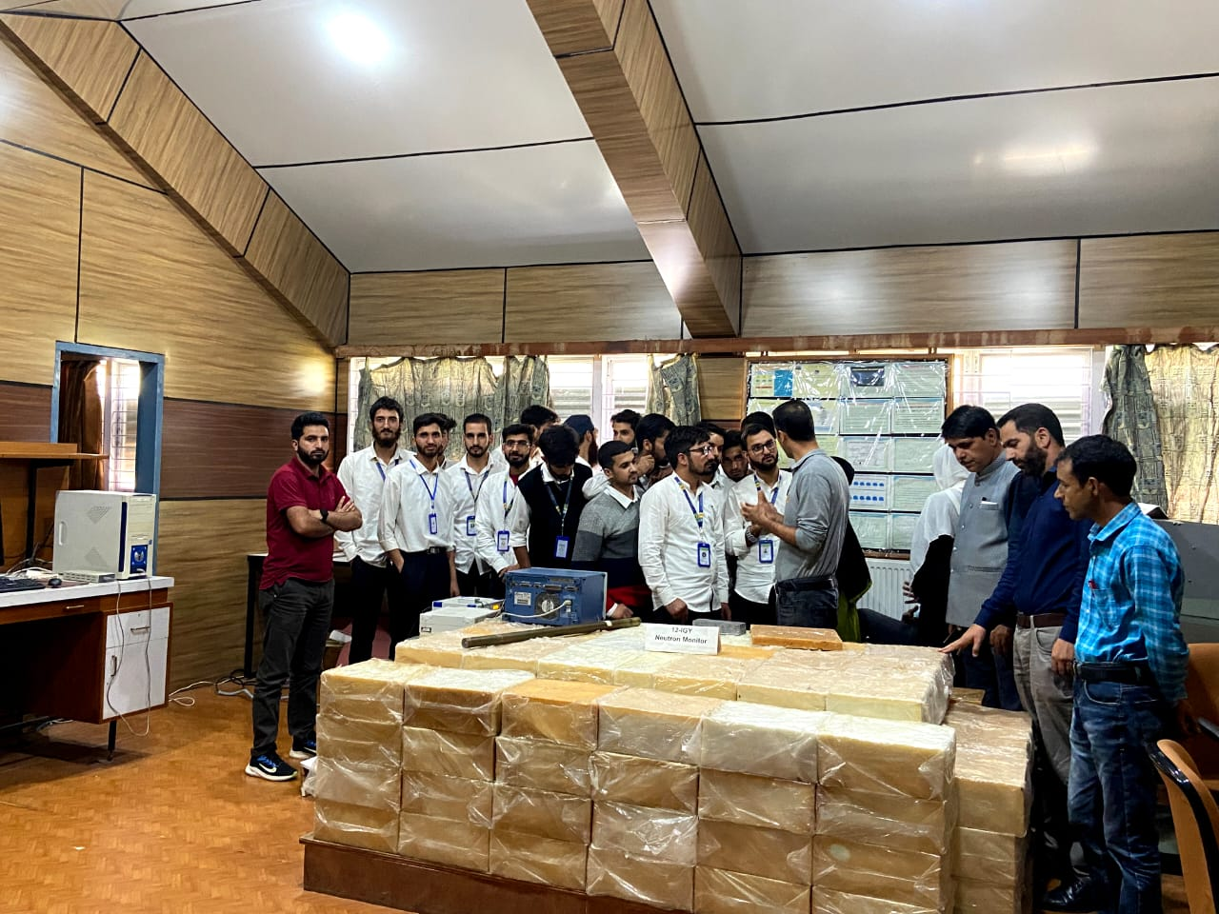

**Head of Department**

**PHYSICS**