DEPARTMENT OF PHYSICS
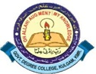
Govt. Degree College, Kulgam

Email:kulgamprincipal@gmail.com Tel. No: 01931-260177
Website: http://gdckulgam.edu.in Fax No: 01931-260177

NO. GDCK/Estt./20/ Date:
REPORT
The students of Department of Physics Government Degree College accompanied by Prof Yasmeen Gull and Dr. Aijaz Ahmad Wani participated in workshop cum Hands-on day long program on Virtual Labs in Physics organised by department Physics NIT Srinagar in collaboration with IIT Delhi on 18th April 2022 at National Institute of Technology Srinagar, Hazratbal Kashmir (J&K)
Virtual lab refers to a virtual teaching and learning environment aimed at developing students’ laboratory skills. As one of the most important eLearning tools, they allow students to conduct various experiments without any constraints to place or time.
The resource persons of the workshop was Dr. T.T. Das (IIT Delhi) and Mr. P. Sharma ,(IIT Delhi). The students and the faculty members interacted with the resource persons and discussed about the importance and use of Virtual Labs.
The aim of the workshop was to enable the students to learn at their own pace and to enthuse them to conduct experiments and to create awareness about Virtual Labs. The resource persons elaborated in detail the following topics during the workshop.
- Empower Faculty to use Virtual Labs
- Integrate Virtual Labs in teaching Learning.
- “Virtual labs as any place, any pace, anytime, any-type labs.
- Virtual Labs as paradigm shift in student-centric education”

At end of the workshop students visited the different labs of Physics Department of NIT and interacted with the students , research scholars and the faculty members.

HOD PHYSICS
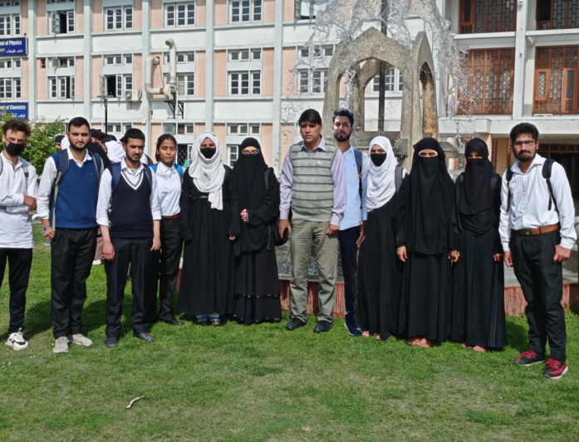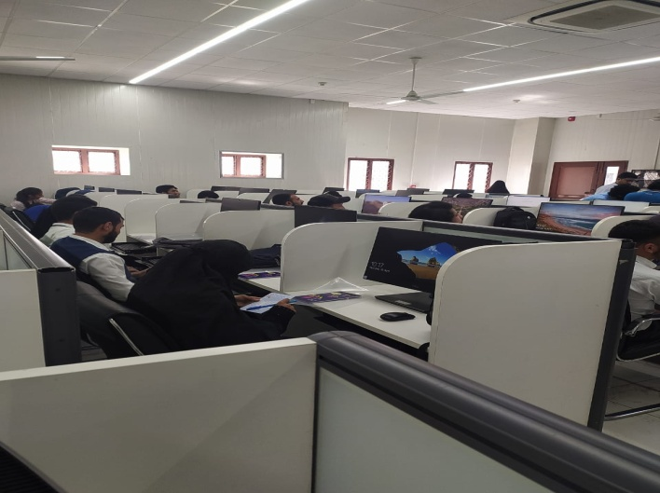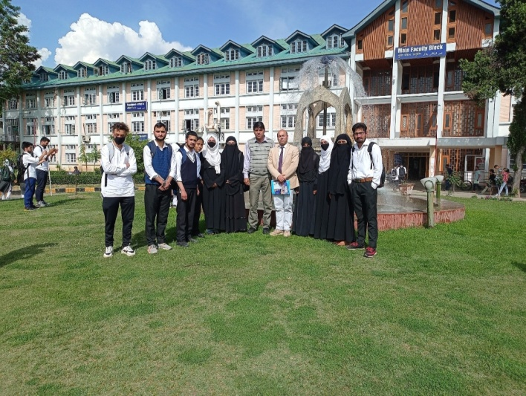
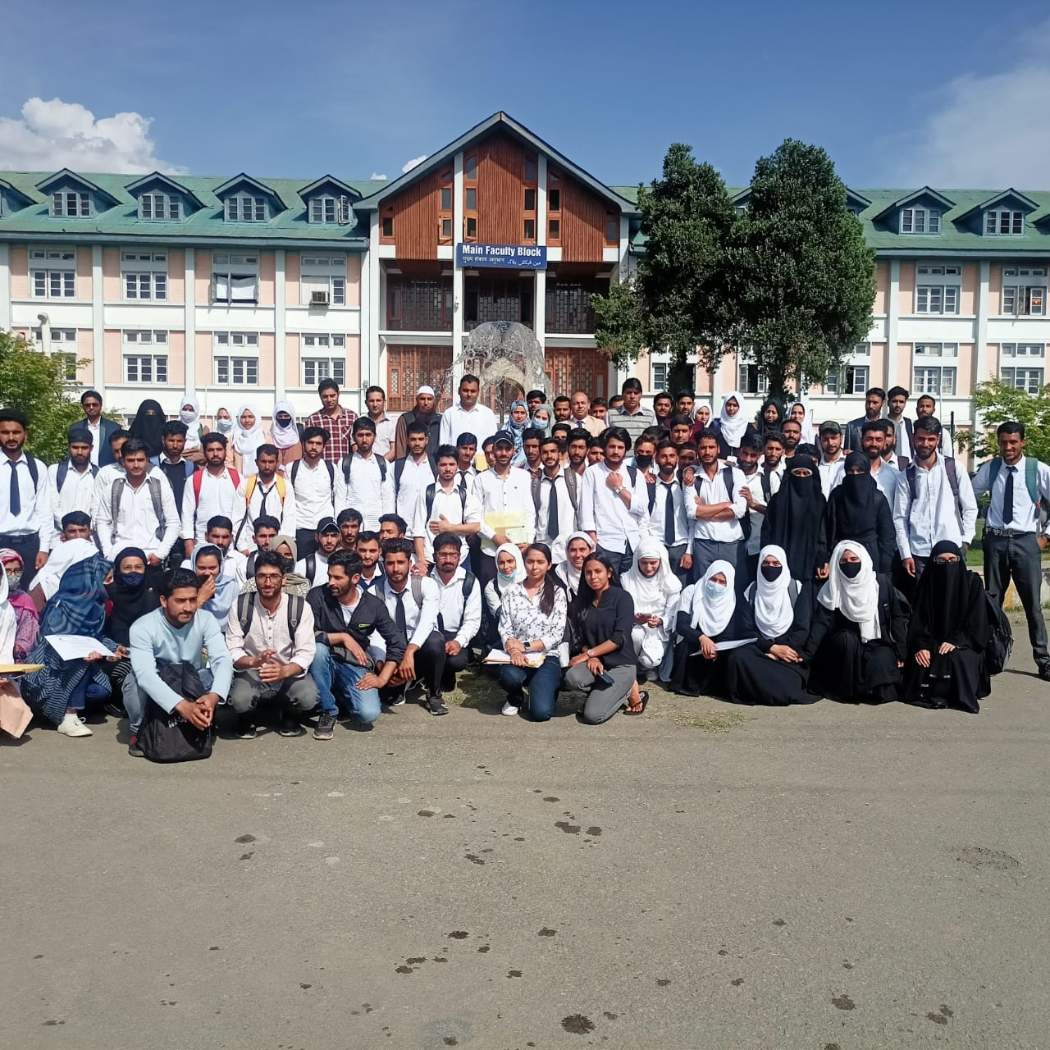

Students of Physics from GDC Kulgam at NIT Sriniagar during a workshop on 18.04.2022

