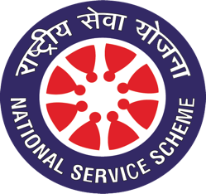
National Service Scheme (NSS) Unit
Govt. Degree College, Kulgam

Email: nss.gdckulgam@gmail.com Tel. No: 01931-260177
Website: http://gdckulgam.edu.in Fax No: 01931-260177
__________________________________________________________________________________________
NSS ENROLMENT FORM
NSS REGISTRATION NUMBER (to be filled by the office): …………………………………………
NAME: ……………………………………………………………………………………

Paste your recent passport size photo here
PARENTAGE: …………………………………………………………………………
PERMANENT ADDRESS: ………………………………………….
………………………………………………………………….
BLOOD GROUP………………………………
SEMESTER: ………………………BATCH: ……………..
CLASS ROLL NUMBER: ……………………………………………….
DATE OF BIRTH (DD/MM/YYYY): ……………………………………..
MOBILE NO: …………………………………………
EMAIL ID: ……………………………………………………………………..
DECLARATION
I hereby affirm that as a volunteer of NSS Unit, I will obey the rules and regulations. I will participate honestly in all the programmes of NSS. If I commit any mistake, I shall forfeit the right to be part of NSS.

Signature of the Student
Form Accepted/Rejected

NSS Programme Officer

