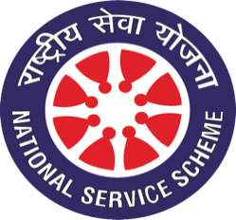
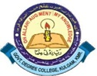
National Service Scheme (NSS) Unit
Govt. Degree College, Kulgam

Email: nss.gdckulgam@gmail.com Tel. No: 01931-260177
Website: http://gdckulgam.edu.in Fax No: 01931-260177
_____________________________________________________________________________________
No: GDCK/NSS/22/40 Date: 01-06-2022
Notice
National Service Scheme (NSS) Unit, in collaboration with Department of Environmental Studies, is organising an Environment Week in the College from 6th-11th June, 2022. The programme would include activities like:
- Campus Cleanliness Drive: 6th June
- Poster Making Competition (on spot): 7th June
- Seminar on Environmental Preservation: 9th June
- Awareness Rally on Plastic use: 11th June
In this regard all the NSS Volunteers of the College are informed to mark their presence on the said days. Those interested to participate in the poster-making competition are asked to register themselves via the link pasted here: https://docs.google.com/forms/d/1pAeXkCwAoot3dKIRNLoliHOi3bAlOJ18hIU9aZKGlM4/edit

Dr. Safeer Ahmad Bhat
NSS Programme Officer

Copy to:
- Worthy Principal for information
- Coordinator IQAC
- HOD Environmental Studies for information and necessary action
- Incharge Website
- Office records

